

**UNIVERSITY OF PETROLEUM & ENERGY STUDIES**

**Dehradun**

**CONTINOUS INTEGRATION**

**AND**

**CONTINOUS DELIVERY**

**Experiment**

**Name: Rithik Chaudhary**

**Course: B. TECH CSE DevOps (2018-22)**

**Roll no.: R171218084**

**Sapid: 500069261**

**CICD LAB- 8**

**Uploading artifact on nexus server using command line**

1. Create repository

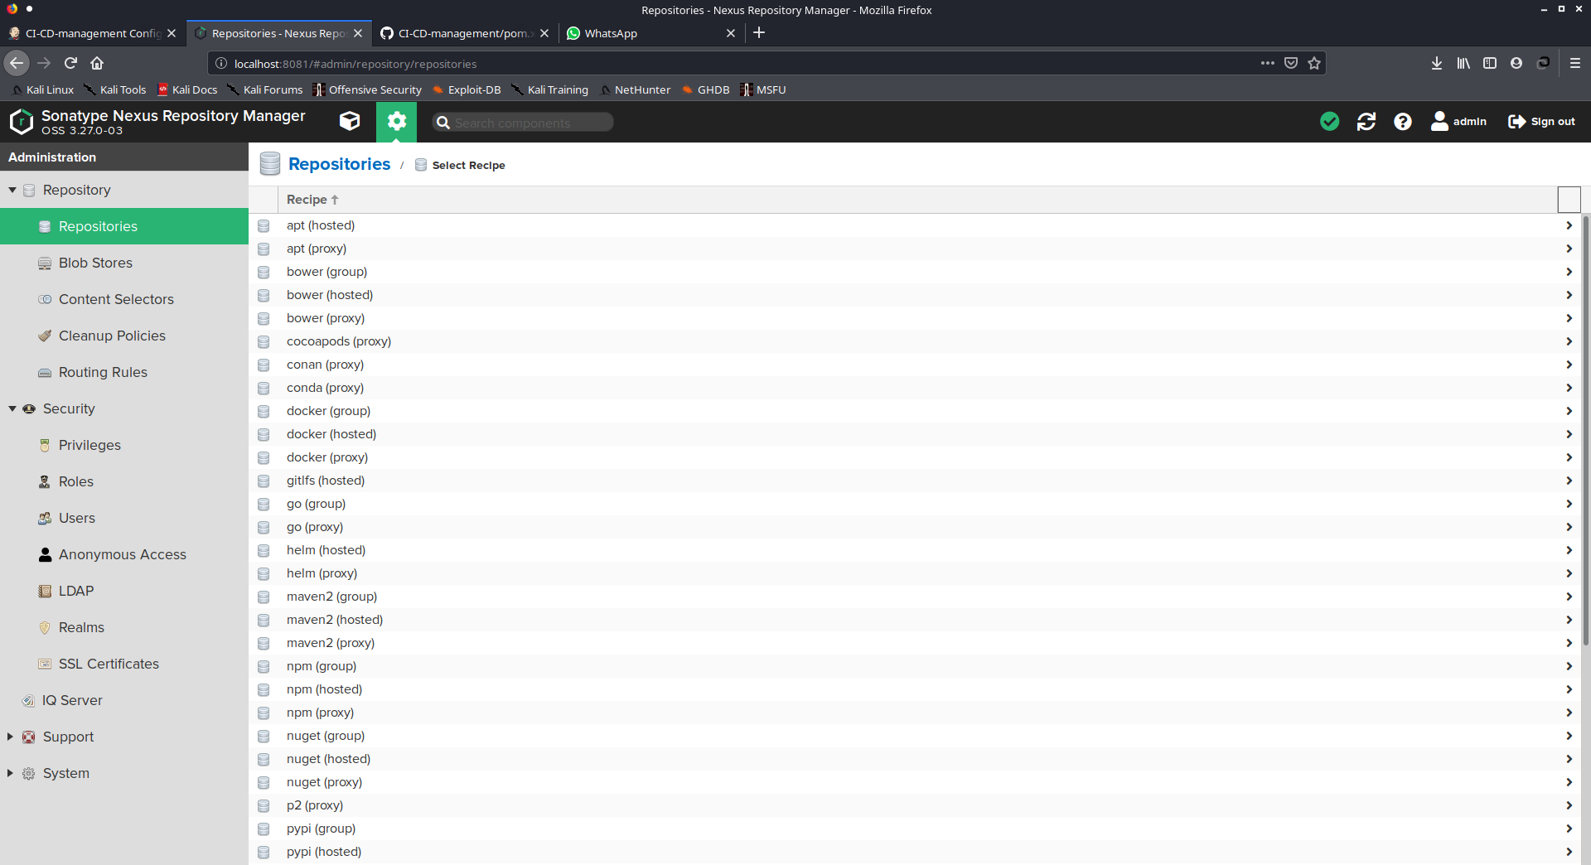

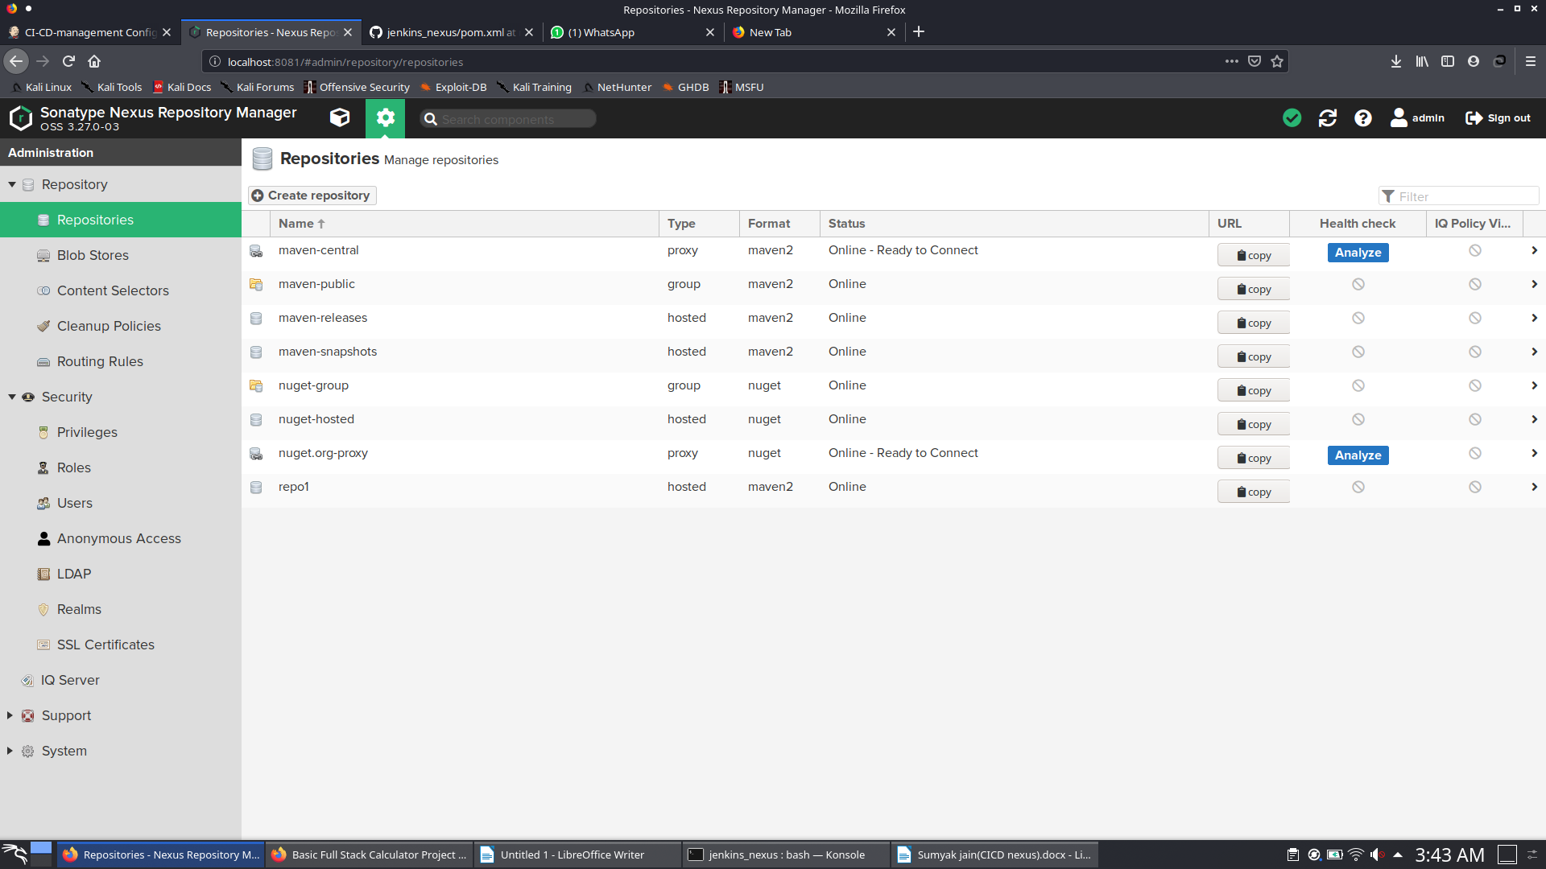

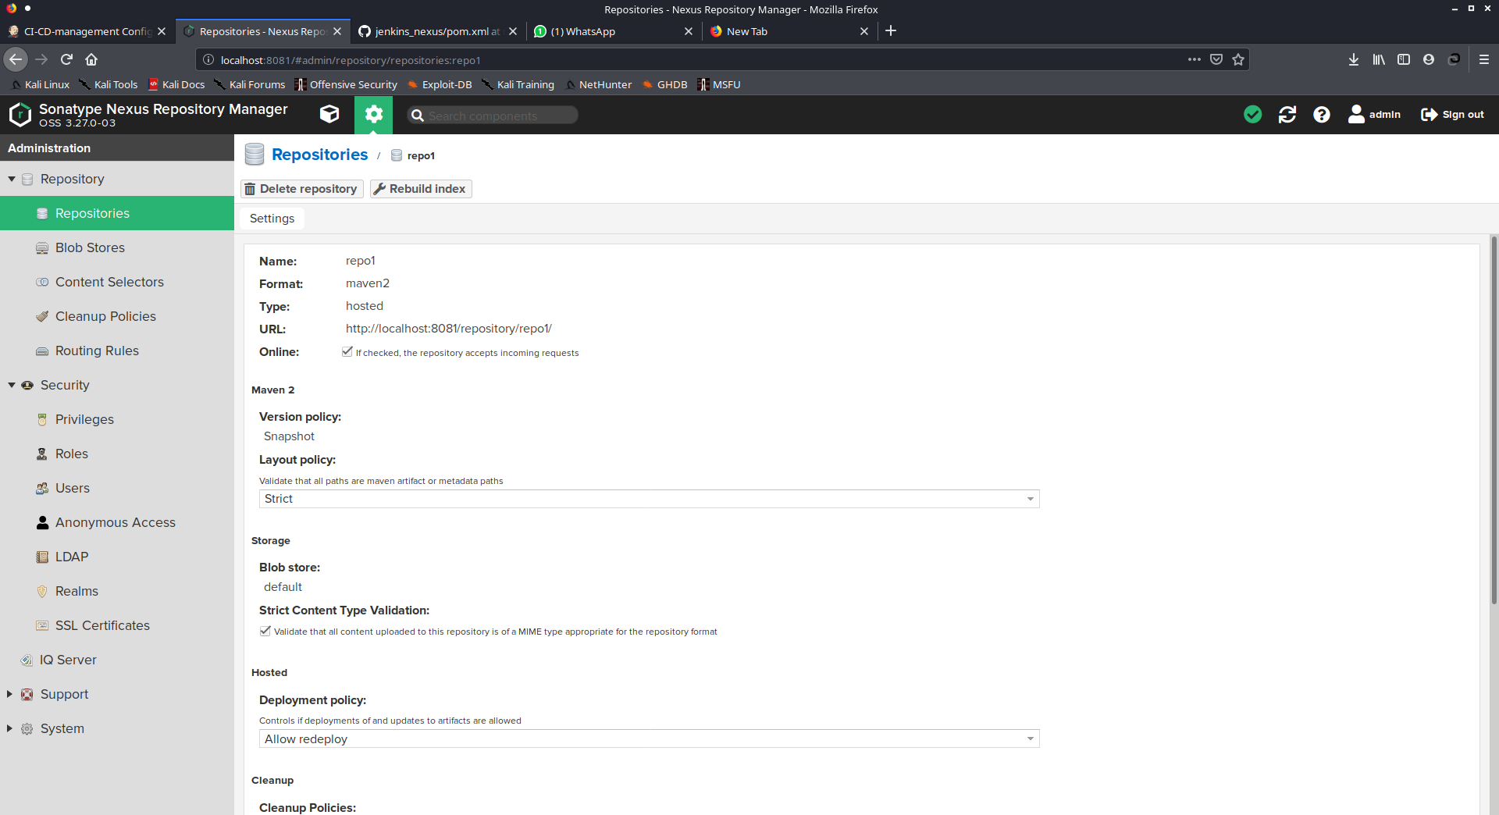

2. Setting server in maven

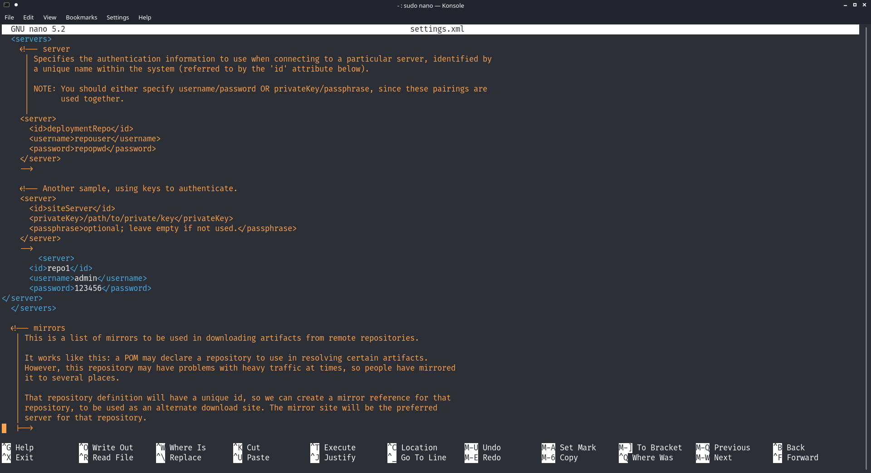

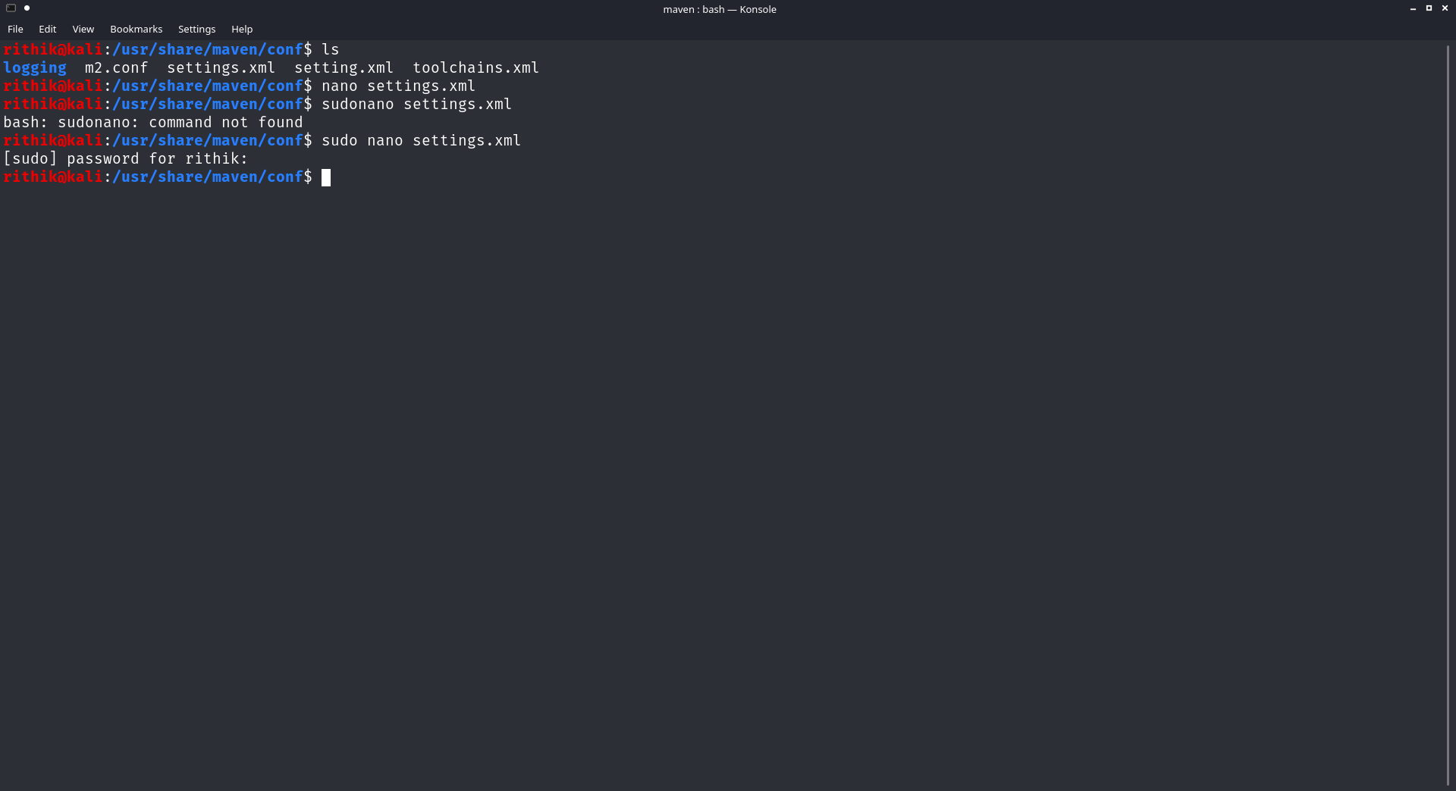

3. configure pom.xml

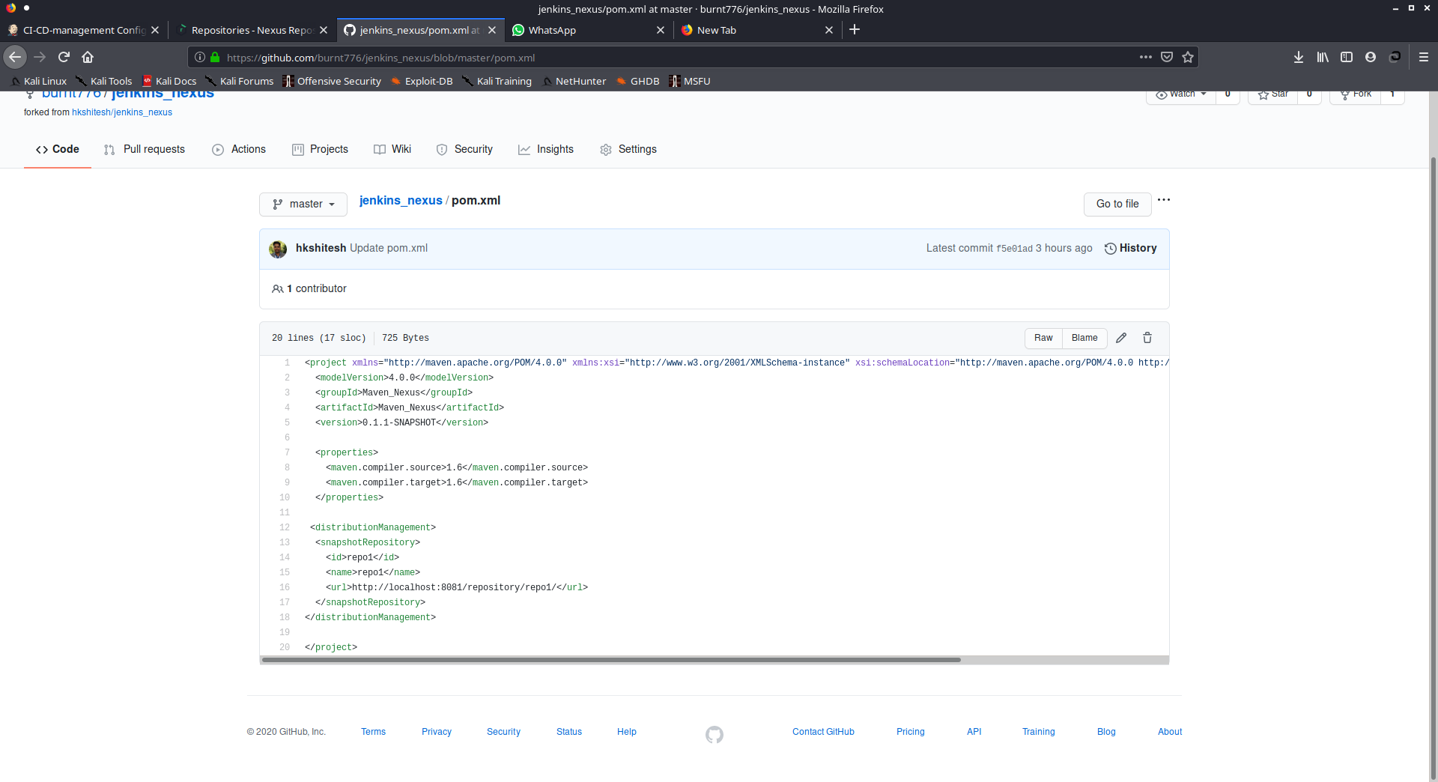

4. Maven goals compile , site ,clean

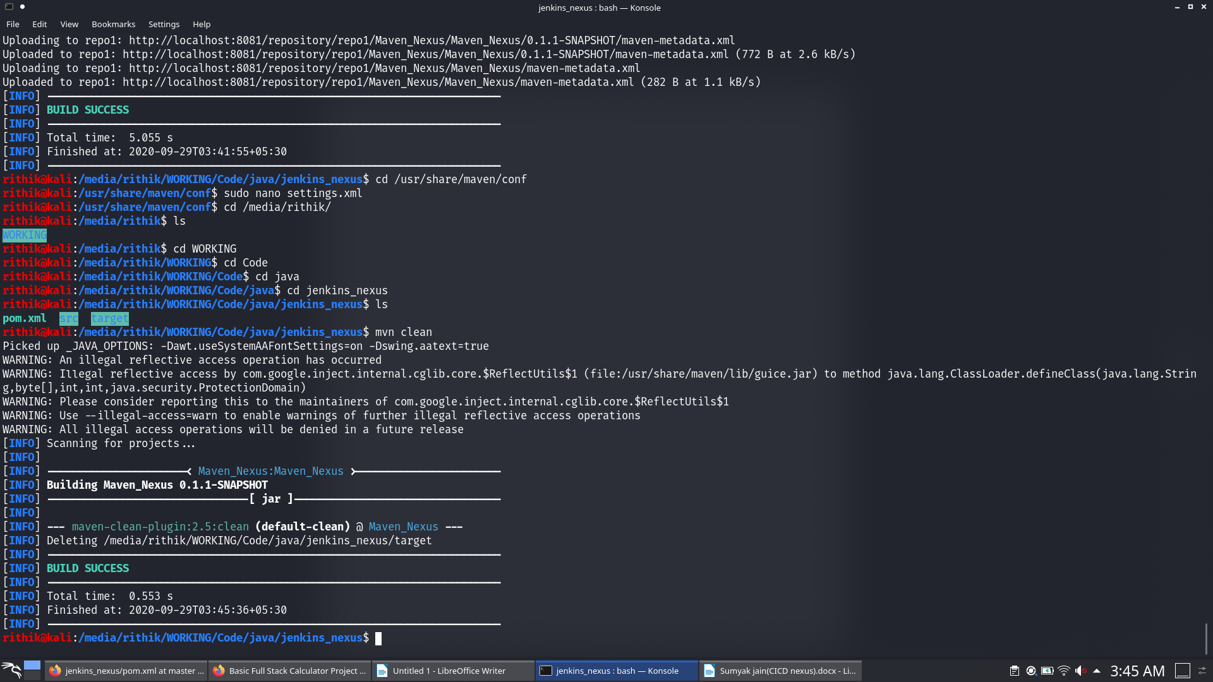

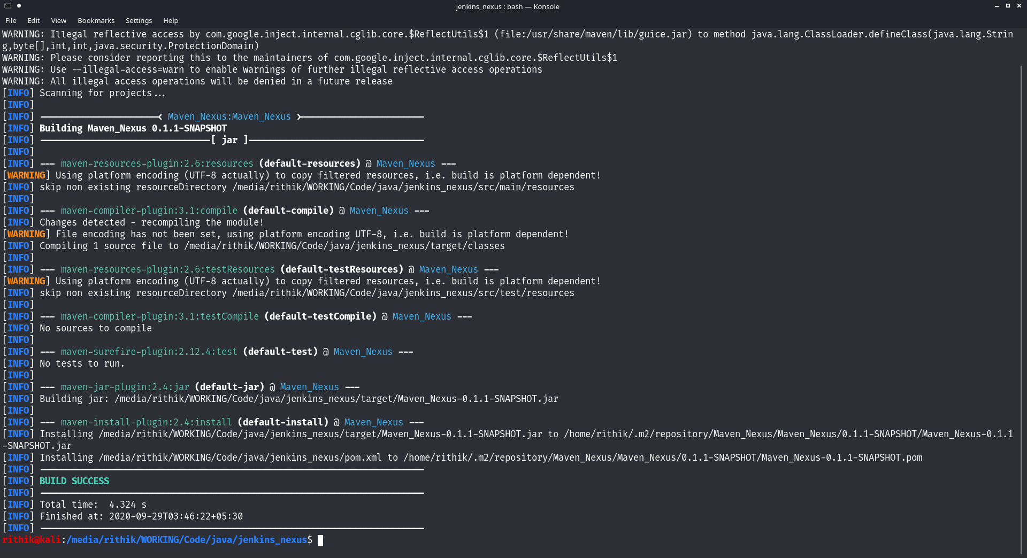

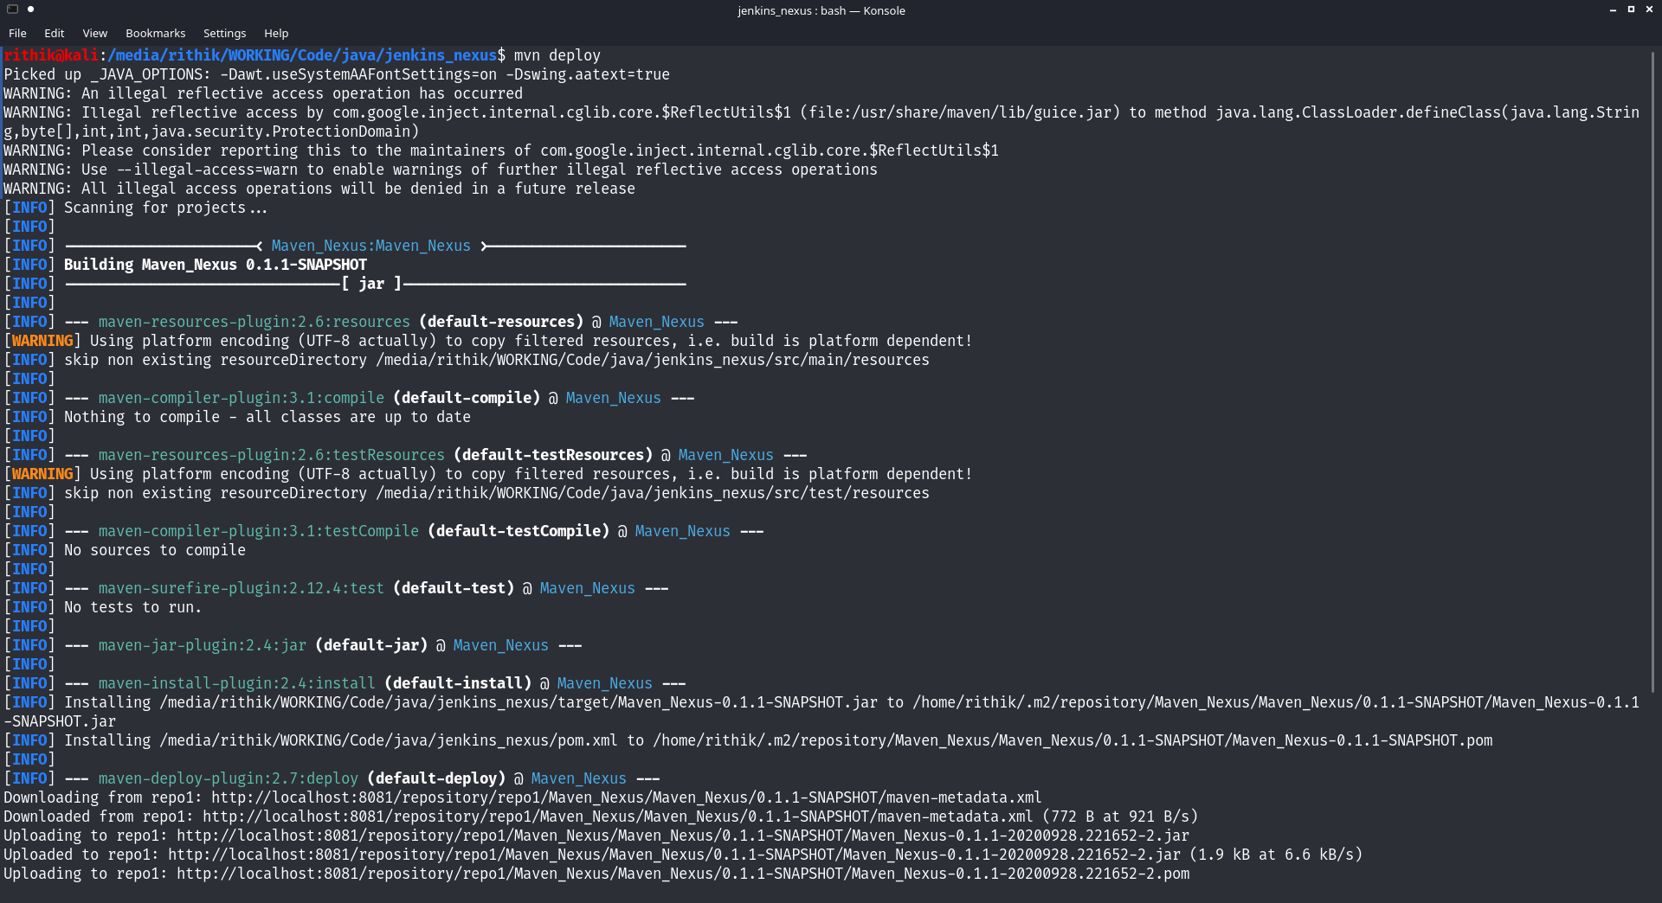

5. Checking nexus

